PAKGEN POWER LIMITED
PROFILE OF DIRECTORS.

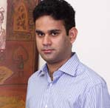
Mian Hassan Mansha

Mian Hassan Mansha has been serving on the Board of various listed companies for several years. He also serves on the Board of Nishat Power Limited, Security General Insurance Company Limited, Nishat Mills Limited, Lalpir Power Limited, Nishat Hotels and Properties Limited, Nishat (Aziz Avenue) Hotels and Properties Limited, Nishat (Raiwind) Hotels and Properties Limited, Nishat (Gulberg) Hotels and Properties Limited, Nishat Hospitality (Private) Limited, Nishat Dairy (Private) Limited, Pakistan Aviators and Aviation (Private) Limited, Nishat Automobiles (Private) Limited, Nishat Real Estate Development Company (Private) Limited and Nishat Agriculture Farming (Private) Limited, Nishat Farm Supplies (Pvt) Limited and Hyundai Nishat Motor (Pvt) Limited.

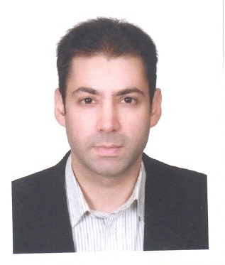
Mr. Aurangzeb Firoz

Mr. Aurangzeb Firoz is a graduate from the Lahore American School and of the University of London. He has recently completed his MBA from Cornell University, USA. His prime experience is focused in the areas of finance, business strategy and operation management. He is a director of City Schools Group and has been instrumental in providing strategic and operational support in driving business expansion into Arab States for City Schools’ (Pvt) Limited.

Mr. Aurangzeb Firoz holds directorships of Lalpir Power Limited, Engen (Pvt) Limited, Educational System (Pvt) Limited, City Educational Services (Pvt) Ltd City Agro (Pvt) Ltd, Smart Education System (Pvt) Ltd, The Smart Schools (Pvt) Ltd, AF & Co (Pvt) Ltd and JF & Co (Pvt) Ltd, his primary interest remains in the development of the new projects, especially in power and Energy and Educational Sector of Pakistan.

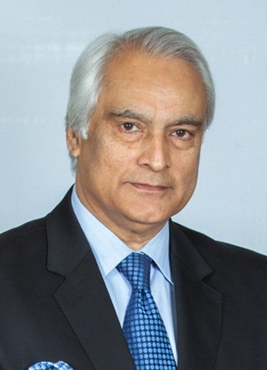
Mr. Shahid Malik

Shahid Malik is a seasoned professional with over 37 years of experience in the Diplomatic Service of Pakistan. He held key assignments as High Commissioner of Pakistan to India (2007-2013) and Canada (2002-2006), with concurrent accreditation as Ambassador to Venezuela and High Commissioner to Trinidad and Guyana. His other diplomatic assignments include Washington (as Minister), Rome (as Charge d’ Affaires), and Tokyo. Mr. Malik has also served as Director General and Additional Foreign Secretary in the Ministry of Foreign Affairs. He also brings with him diversified academic experience being part of the faculty at various universities worldwide, and has represented Pakistan at international forums including the UN (United Nations), Commonwealth, OIC (Organization of Islamic Countries), NAM (Non-Aligned Movement) and SAARC (South Asian Association for Regional Cooperation).

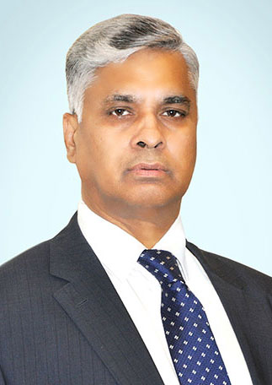
Mr. Hassan Nawaz Tarar

Mr. Hassan Nawaz Tarar is a seasoned civil servant having 34 years of rich administrative experience in a broad range of public services. He has held key assignments in the areas of district administration, public security, finance, international development cooperation, taxation, urban management, planning and HR development among others. He retired as the Federal Secretary Planning, Development & Reform in 2015. He has served on the Boards of corporate bodies including CAA, PSO, PASSCO, MCBESSS, as well as national policy and planning platforms. He has attended several national and international conferences and training modules, including executive development programmes in the John F. Kennedy School of Government at Harvard University and Lee Kuan Yew School of Public Policy, Singapore. Mr. Tarar obtained his Master’s in Development Administration from Birmingham University, UK and also holds Master’s Degrees in Political Science and Journalism in addition to a LLB from the University of Punjab. He works at MCB Bank Ltd.

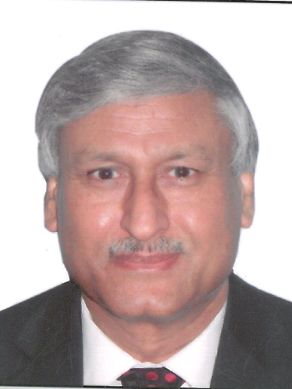
Dr. Arif Bashir

Dr. Arif Bashir holds PhD degree in Chemical Engineering and has over 33 years of experience in the fields of project planning and execution; operation and maintenance of Cement Plant, power plants, paper plant etc. Currently, he is working as Director (Technical and Operations) of D. G. Khan Cement Company Limited (DGKCC) and responsible for the smooth operation and maintenance of cement production lines having capacity over 4.8 million tons/year. Captive Power Plants of about 100 MW capacity. Paper Sack plant having production capacity of 500,000 bags/day. Also responsible for Captive Coal based Power Plant, Alternate Fuels, Waste Heat Recovery projects of DGKCC.

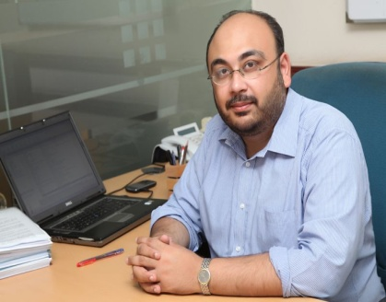
Mr. Badar Ul Hassan

Mr.Badar is a dynamic finance professional with exceptional analytical and management skills for developing and implementing financial systems, strategies, processes and controls that significantly improve organizational functions and systems leading to cost-reduction, automation and goal-surpassing strategies.
He also serves on the Board of Security General Insurance Company Limited and Nishat Paper Products Limited he is also Chief Financial Officer of Nishat Mills Limited, Nishat Dairy (Pvt) Limited, Nishat Hospitality (Pvt) Limited and Nishat Linen ( Pvt) Limited.
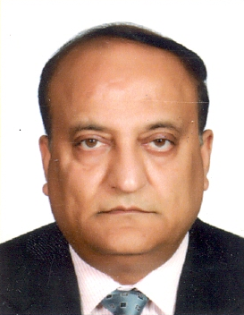

Mr. Farrukh Ifzal

Mr. Farrukh Ifzal is a Fellow Member of The Institute of Chartered Accountants of Pakistan. He has over 32 years of diversified experience in the field of Accounts, Finance, Legal and General Management. He also served in Punjab Industrial Development Board. He is currently serving as Managing Director of Nishat Chunian Power Limited.

